Practical no. 11
Name :- Danish Altaf Solkar Enrolment no. :-24111590805
Class :- CO3K – B Subject :- OOP
Aim :- WAP to implement inheritance shown below figure. Assume suitable member function.
Program :-
#include<iostream.h>
#include<conio.h>
class Furniture{
public:
char material[30];
int price;
};
class Table:public Furniture{
public:
int height;
char surface[50];
void accept(){
cout<<"\nEnter the Material :- ";
cin>>material;
cout<<"\nEnter the Price :- ";
cin>>price;
cout<<"\nEnter the Height of Table :- ";
cin>>height;
cout<<"\nEnter the Surface of Table :- ";
cin>>surface;
}
void display(){
cout<<"\nMaterial :- "<<material;
cout<<"\nPrice :- "<<price;
cout<<"\nHeight of Table :- "<<height;
cout<<"\nSurface of Table :- "<<surface;
}
};
void main(){
Table t;
clrscr();
t.accept();
cout<<"\n---Details of the Table---";
t.display();
getch();
}
OUTPUT:-
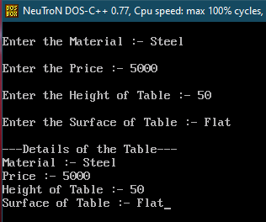

Aim :- WAP to implement following multi-level inheritance.
Program :-
#include<iostream.h>
#include<conio.h>
class Person{
public:
char name[30];
char gender[20];
int age;
};
class Employee:public Person{
public:
int emp_id;
char company[50];
int salary;
};
class Programmer:public Employee{
public:
int no_of_prog_lang_known;
void accept(){
cout<<"\nEnter your Name :- ";
cin>>name;
cout<<"\nEnter your Gender :- ";
cin>>gender;
cout<<"\nEnter your Age :- ";
cin>>age;

cout<<"\nEnter your Employee Id :- ";
cin>>emp_id;
cout<<"\nEnter your Company :- ";
cin>>company;
cout<<"\nEnter your Salary :- ";
cin>>salary;
cout<<"\nEnter the no. of Programming Languages :- ";
cin>>no_of_prog_lang_known;
}
void display(){
cout<<"\nName :- "<<name;
cout<<"\nGender :- "<<gender;
cout<<"\nAge :- "<<age;
cout<<"\nEmployee Id :- "<<emp_id;
cout<<"\nCompany :- "<<company;
cout<<"\nSalary :- "<<salary;
cout<<"\nNumber of Programming Languages known :- "<<no_of_prog_lang_known;
}
};
void main(){
Programmer p;
clrscr();
p.accept();
cout<<"\n---Programmer Details---";
p.display();
getch();
}

OUTPUT:-
